

**Faculty of engineering - Shoubra**

**Benha University**

**Research Article / Research Project / Literature Review**

in fulfillment of the requirements of

|  |  |
| --- | --- |
| **Department** | **Engineering Mathematics and Physics** |
| **Division** | **--------------------------** |
| **Academic Year** | **2019-2020 Preparatory** |
| **Course name** | **Computer** |
| **Course code** | **ECE001** |

**Title: -**

**Build a website on recent computer engineering topics**

By:

|  |  |  |  |
| --- | --- | --- | --- |
|  | Name | Edu mail | B.N |
| 1 | Amr Abd-Elmegeed  Mahmoud | amr196642@feng.bu.edu.eg | 579 |

**Approved by:**

|  |  |
| --- | --- |
| Examiners committee | Signature |
| **Dr.Ahmed Bayoumi** |  |
| **Dr.Shady Elmashad** |  |
| **Dr. Abdelhamid Attaby** |  |
|  |  |
|  |  |

**Research objectives**

**Build a website on recent computer engineering topics for example: build website on internet of things.**

**Abstract**

The definition of the Internet of Things has evolved due to the convergence of multiple technologies, real-time analyzes, machine learning, commodity sensors, and embedded systems. The traditional areas of embedded systems, wireless sensor networks, control and automation systems (including home and building automation) and others contribute to enabling the Internet of Things. In the consumer market, IoT technology is highly synonymous with products related to the concept of "smart home", which covers devices and devices (such as lighting fixtures, thermostats, home security systems, cameras, and other home appliances) that support one or more popular ecosystems, and can Control it across devices connected to this ecosystem, such as smartphones and smart speakers.

**Table of contents**

|  |  |
| --- | --- |
| **Subject / section** | **Page** |
| **Research objective** | **1** |
| **Abstract** | **2** |
| **Screen shots** | **6-7-8** |
| **Source coding** | **9-10** |
| **References** | **11** |
|  |  |

**List of Figures (If any)**

|  |  |  |
| --- | --- | --- |
| **Figure I.D** | **Description** | **Page** |
|  |  |  |
|  |  |  |
|  |  |  |
|  |  |  |
|  |  |  |
|  |  |  |

**List of Tables (If any)**

|  |  |  |
| --- | --- | --- |
| **Table I.D** | **Description** | **Page** |
|  |  |  |
|  |  |  |
|  |  |  |
|  |  |  |
|  |  |  |
|  |  |  |

* **Screenshots :**

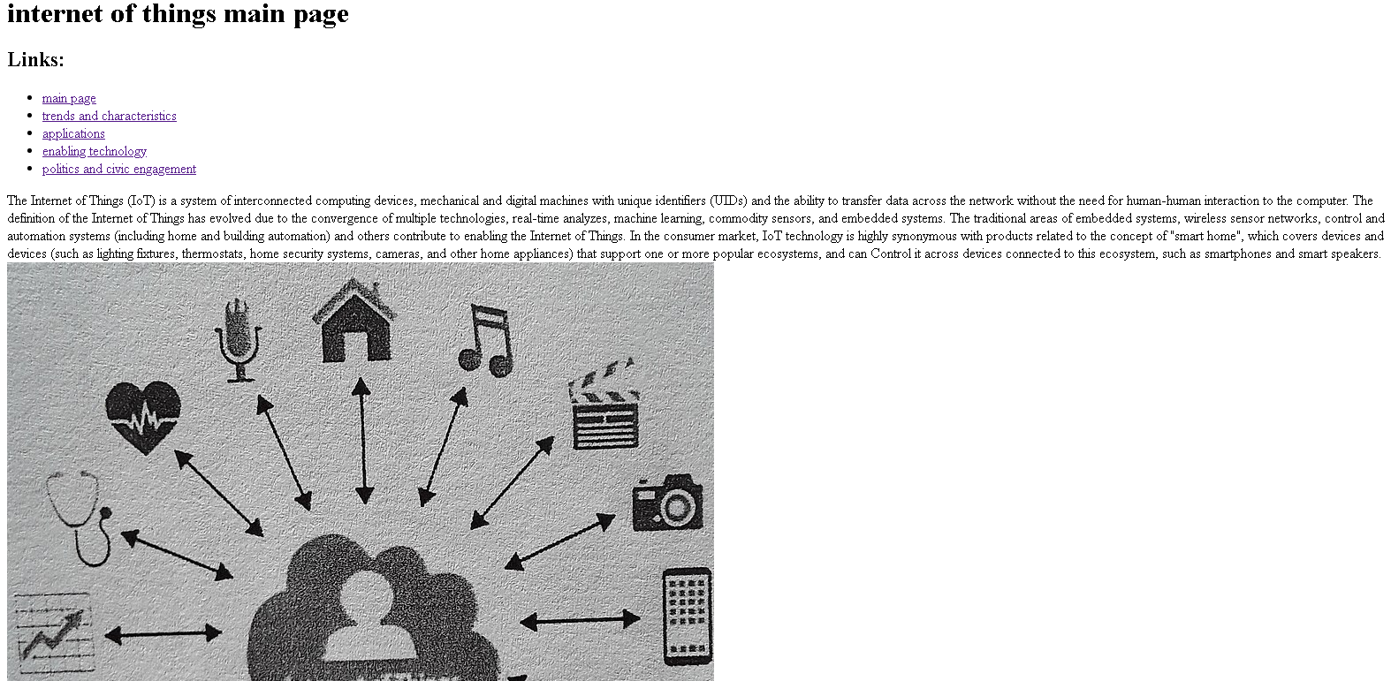

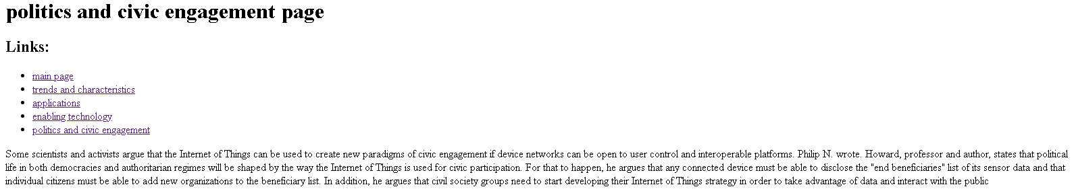

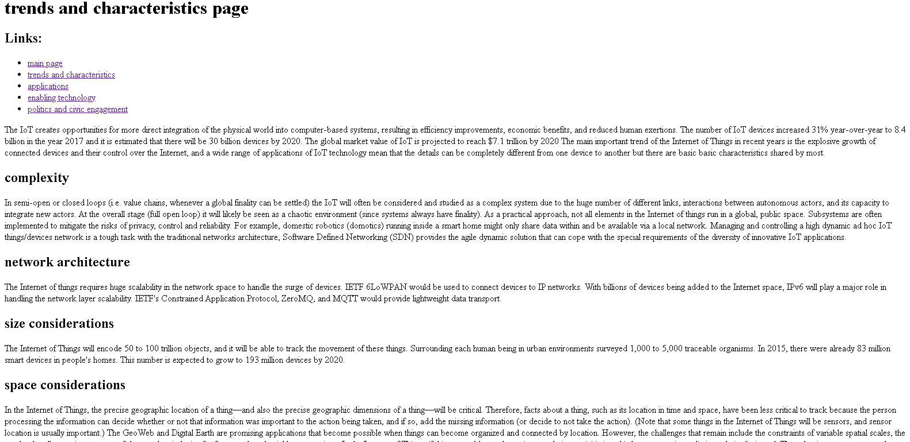

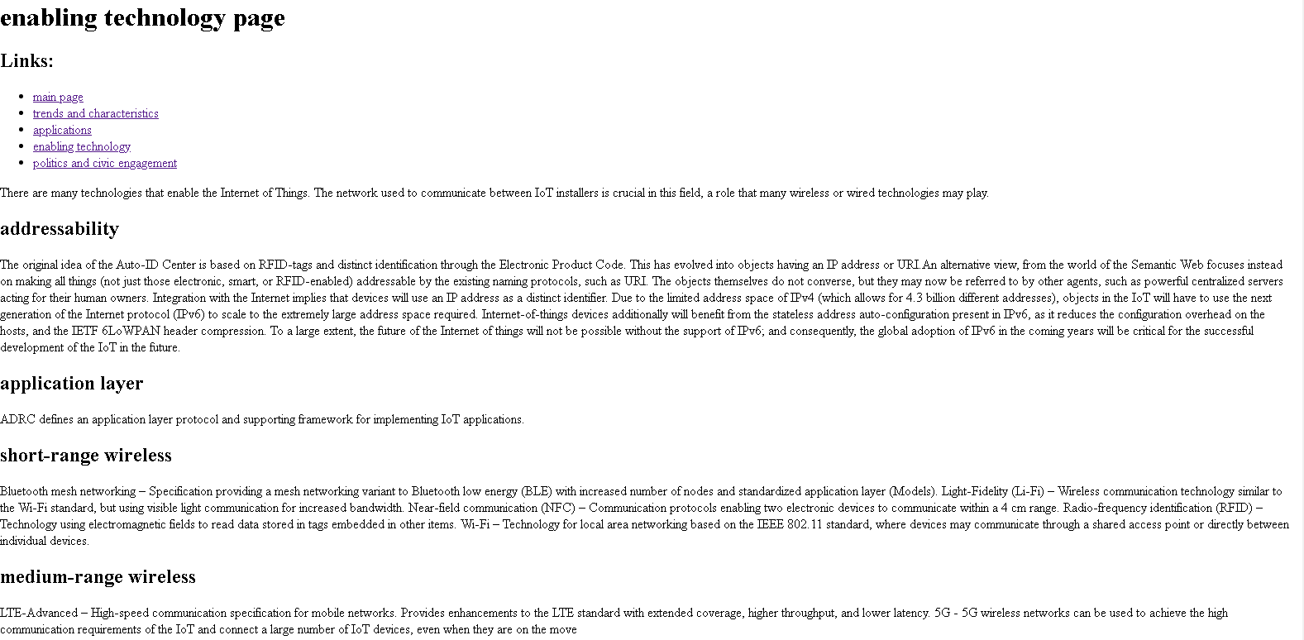

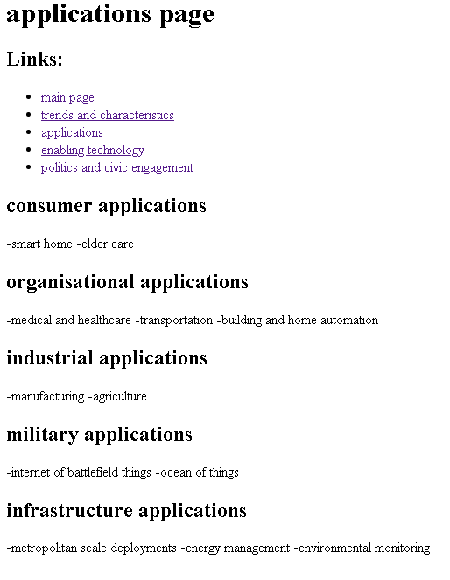

* **Source coding :**

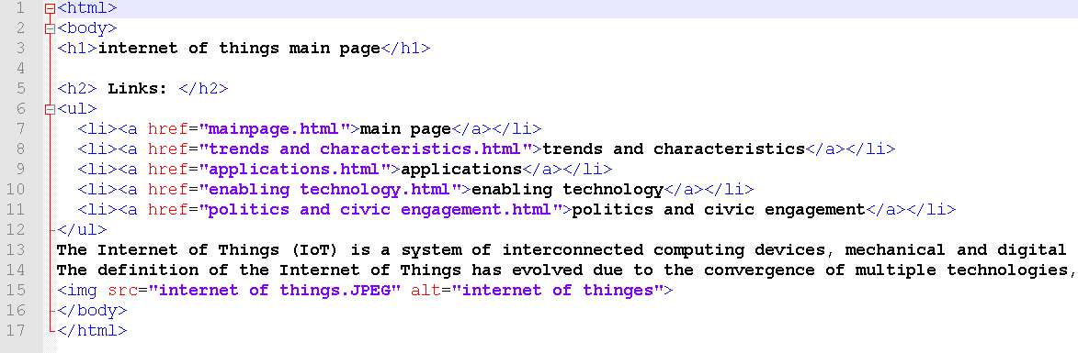

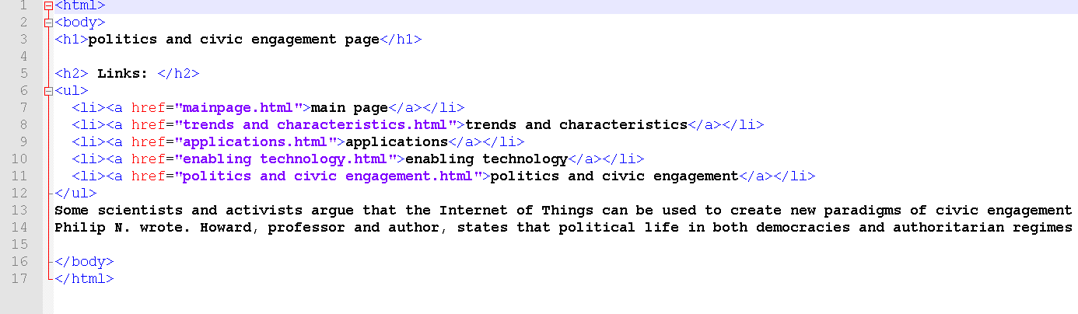

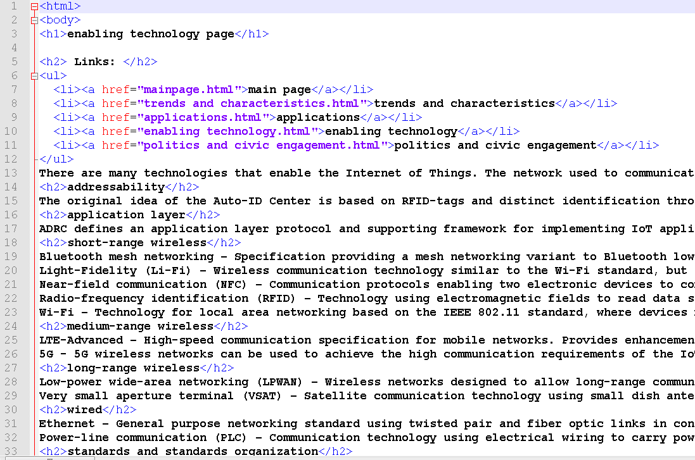

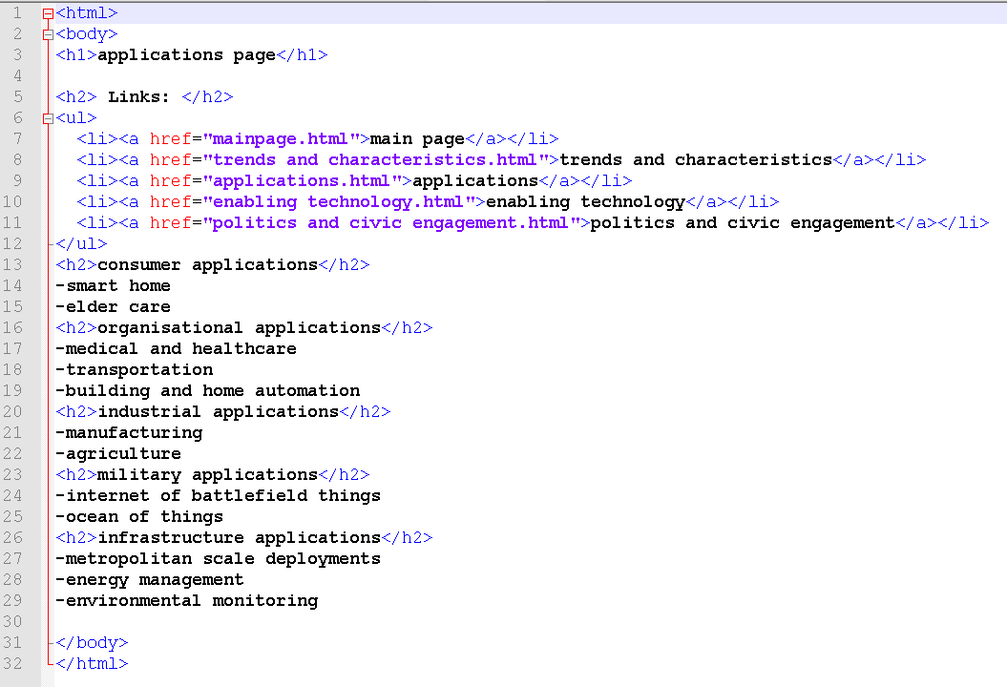

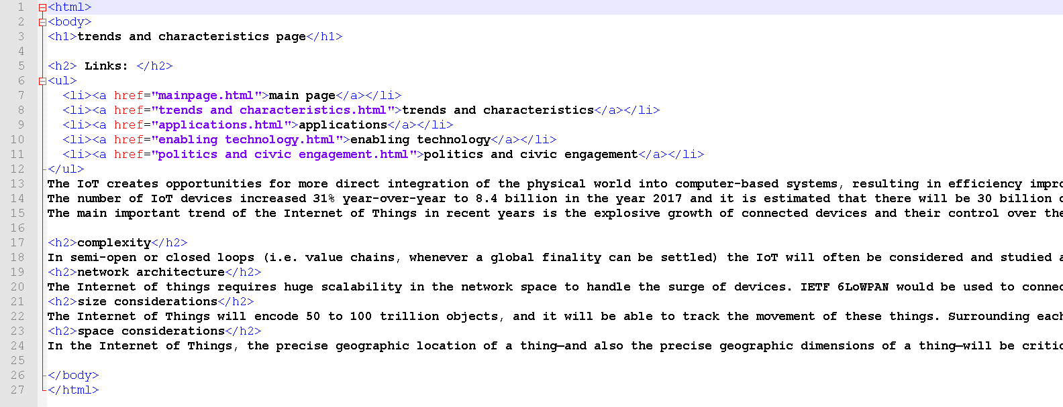

**References**